**STAT5140, Homework #1, Allen Baumgarten**

**Question 3**

1. Consider *φ ~ Uniform*(-π, π). Plot the process for *t* ε (0, 1000):

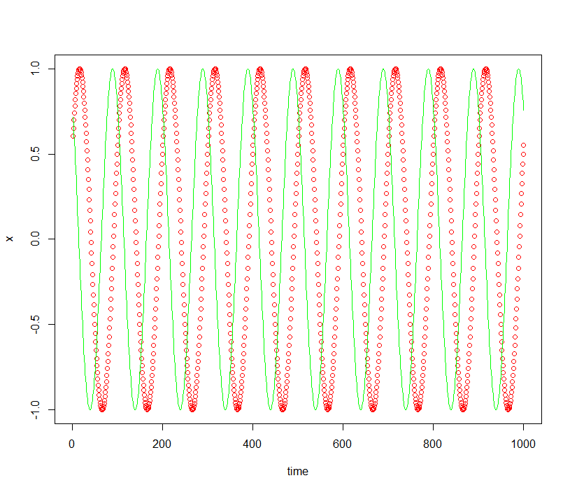

set.seed(111)

num = 1

phi = runif(num, -pi, pi)

time = seq(1,1000, by=1)

x <- sin(2*pi/100*time + phi)

rho = runif(num, 0, pi)

y <- sin(2*pi/100*time + rho)

plot(time, x, col="red")

lines(time, y, col="green")

1. Consider *φ ~ Uniform*(0, π). Plot the process for *t* ε (0, 1000):

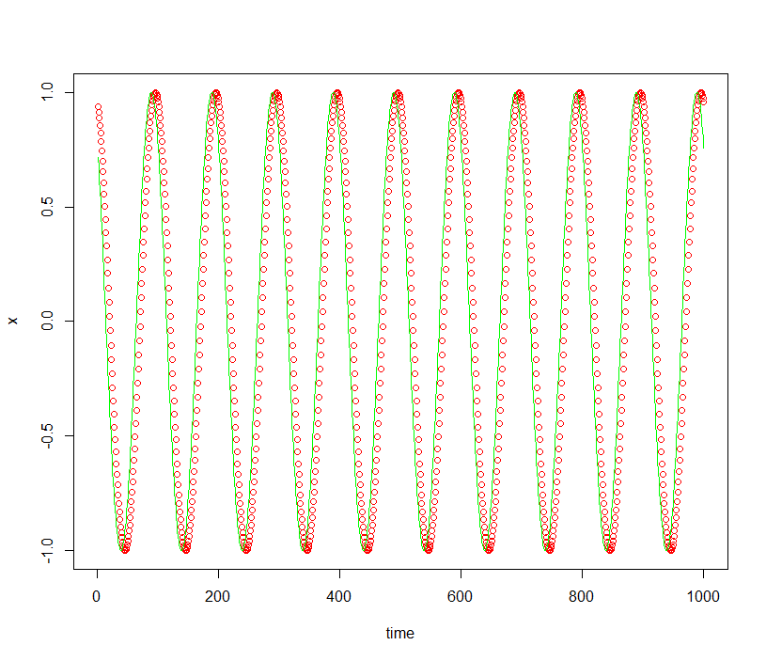

set.seed(111)

num = 1

phi = runif(num, 0, pi)

time = seq(1,1000, by=1)

x <- sin(2*pi/100*time + phi)

rho = runif(num, 0, pi)

y <- sin(2*pi/100*time + rho)

plot(time, x, col="red")

lines(time, y, col="green")

1. observations: the time measurement in the second tends to align more closely with the plotted simulation than in the first graph.

**Question 5**

In a few lines, write your comments for each [of the four plots]:

For TS1, Australian red wine sales, the plot seems to show peaks and troughs happening roughly every 12-15 periods. Tough to say without increments of 5 plotted but I think this has monthly data on the x-axis. Immediately preceding and following each peak, there is a smaller peak on either side of the high one. Also, the series as a whole seems to be increasing.

For TS2, Airline passenger data, unless I am miscounting, this data seems to show 12 distinct data points which repeat. Each set of 12 points starts with a trough, goes up to small peak, dips, then goes up to a high peak and then drops precipitously. This pattern then repeats. These sets of patterns are collectively increasing.

For TS3, Monthly accident data, this appears to be monthly data with repeating patterns every 12 months. There is a dramatic climb to a peak, then a drop to a lower peak, and then a drop to a trough which then starts the pattern over. These sets of patterns seem to start a bit high collectively, dip collectively from the 30-45 month range, and then gradually increase a bit.

For TS4, Australian monthly electricity production, is first of all gradually increasing through time with an overall gentle curve upward. Each year, it seems, electricity is produced up to a small peak, followed by a small drop, then followed by a large spike in production, followed by a lower peak, and then down, all of which repeats for the next year.